**TANYA MISHRA**

**1BM18CS117**

**Program to CHECK WHETHER THE NUMBER IS ZERO/ POSITIVE/ NEGATIVE using Test Operator**

echo "Enter a number"

read num

if [ $num -eq 0 ]

then

echo "The given number is zero"

elif [ $num -gt 0 ]

then

echo "The given number is positive"

else

echo "The given number is negative"

fi

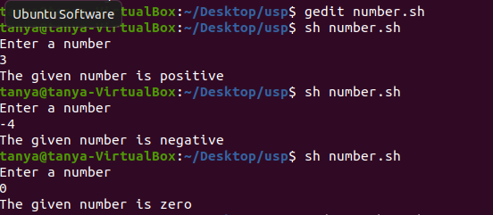

**Shell script to find the BIGGEST OF THREE NUMBERS using test operator and logical and && operator.**

echo "Enter 3 numbers"

read num1

read num2

read num3

if [ $num1 -gt $num2 ] && [ $num1 -gt $num3 ]

then

echo "$num1 is the biggest"

elif [ $num2 -gt $num1 ] && [ $num2 -gt $num3 ]

then

echo "$num2 is the biggest"

elif [ $num3 -gt $num1 ] && [ $num3 -gt $num1 ]

then

echo "$num3 is the biggest"

else

echo "Equal numbers"

fi

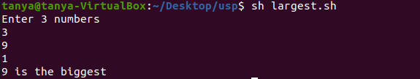

**Write a shell Script to accept two command Line parameters Using Positional parameter technique display the file attributes of the parameters .Use appropriate if conditions in the program to check the number of arguments**

if test $# -eq 0  
then  
echo "No parameters passed"  
elif test $# -eq 2  
then  
echo `ls -l $1` || echo "$1 Not found "  
echo `ls -l $2` || echo "$2 Not found "  
else  
echo "Pass 2 parameters only"  
fi

